Title of the Abstract (Times New Roman, 14 pt, Bold, Center Aligned)
1st Author,¹ 2nd Author², and 3rd C.D. Author^{2,}* (Times New Roman, 11 pt, Bold, left aligned)
¹Author’s affiliation, Country
²Author’s affiliation, Country
*Corresponding author: E-mail address (Times New Roman, 11 pt, Italic, left aligned)

Text written in English
A4 format
Top and bottom margins should be 25 mm and side margins should be 20 mm
Maximum two pages, including figures, tables, and references
Underline the presenting author’s name and asterisk (*) the corresponding author’s name
Name(s) should begin with full first name, middle initial and last name

The main text is given in font Times New Roman, 11-point and divided into four sections:
Introduction, Experimental, Results & Discussion, Conclusions.

1. Introduction (Times New Roman, 11 pt, Bold)
Text

2. Experimental
Text

3. Results and Discussion
Captions of Tables and Figures are given in 10-point and separated by a single line spacing from the text body. Text within the table and figure and footnotes for the table should not be sized less than 9-point (see below examples).

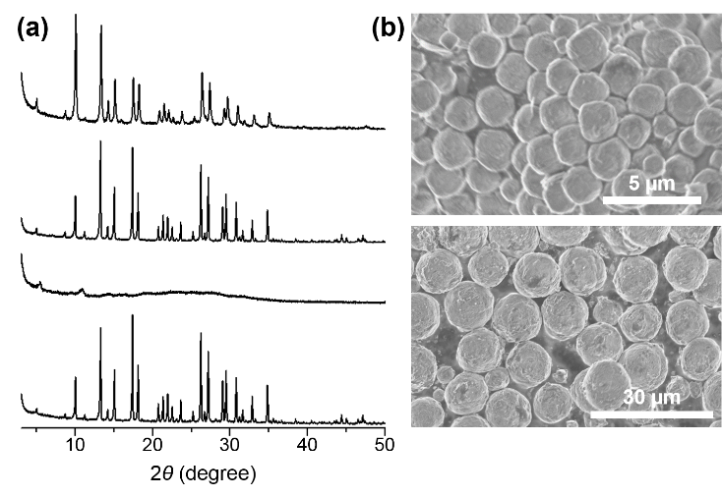
Figure 1. (a) Text. (b) Text.
Table 1. Representative Synthesis Conditions and Resultsª
 | gel composition |  |  | product
run | NaOH/SiO₂ | SiO₂/Al₂O₃ | H₂O/SiO₂ | product
ª Text...

All bibliographical references¹ are indicated in 11-point in the order that they appear with superscripted numerals (starting from 1) in the text.

4. Conclusions
Text

References
- ACS style, Author, A. B.; Author, C. -D.; Author. E. F. J. Am. Chem. Soc. 1965, 87, 1234-5678.

